WholisticPT

1866 Harrier Avenue

Clermont, Florida, 34711

954-802-6330

MEDICAL HISTORY/SUBJECTIVE REPORT
Please take a few minutes to fill out this survey.

Personal Information
First Name | Last Name | Gender | Age
Address | City | State | ZIP Code
Email | Phone

The reason why you are seeking Myofascial release Therapy

Check all that apply
Reducing pain level Post-Surgical Scar adhesions Improving Function
Increase Mobility Improving posture Greater wellness
Other

Please shade areas of pain on the diagram below:

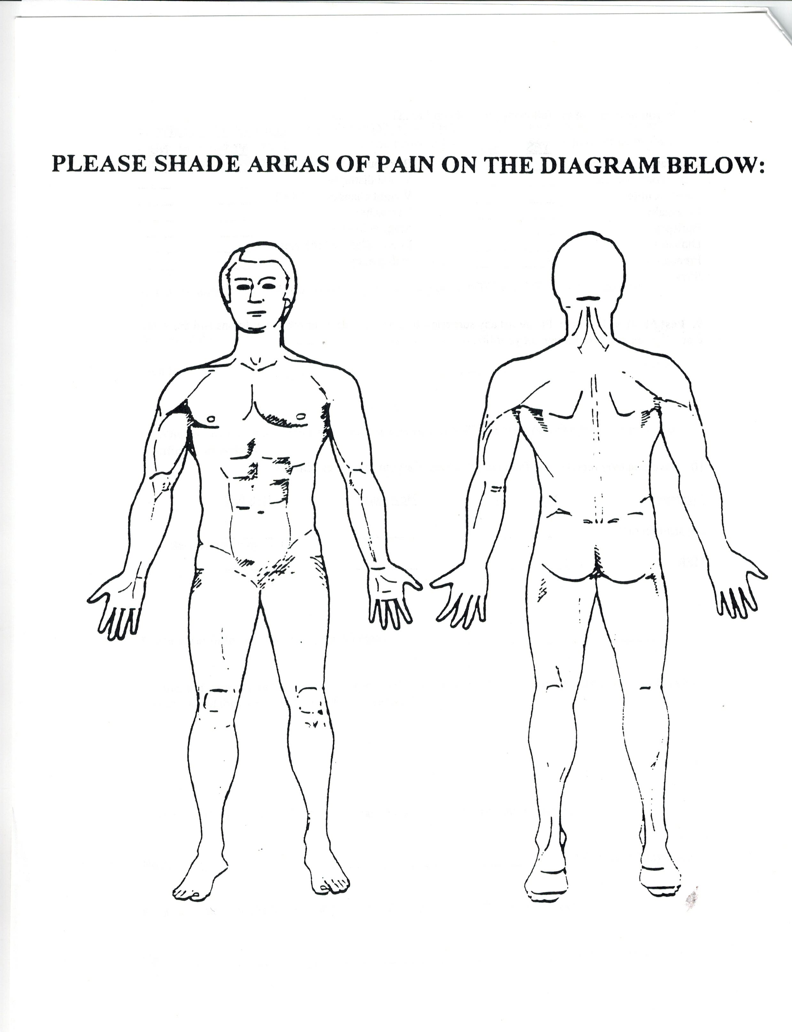

Pain measure

My pain is:
Constant Intermittent (comes and goes) Sporadic
Changes depending on activity Changes depending on the time of the day

Other

Please check and choose the appropriate number
0 no pain
1 You are pretty aware of pain but it allows you to continue with activities
2 Pain makes you stop the activity
3 Very intense (cold sweats, nausea, shakiness)
4 Needs help immediately, ER or in your way to ER

How long have you been experiencing symptoms?

How did the pain start?

Since onset your pain is
Better Worse The same

How would you describe your pain

Check all that apply
Sharp Dull/ache Burning
Shooting Tightness Pressure
Cramping Spasms
Other

What activities aggravate the pain?

Is there anything that gives relieve? (Heat, cold, stretch, rest, etc.)

Are you using any pain medication?

Have you been treated for the same condition/complaint? If so, please explain in what kind of treatment.

Any other information that you feel your therapist should know

Past medical record

List all medical conditions that you have had in the past or present

List all surgeries you have had (include cosmetic procedures)

List all medication you are currently taking (include over the counter)

List any traumas major and minor (falls, accidents, etc.) that you recall

Are you under stress normally?

Have you recently experienced a major life stressor? If yes, please explain.

What are your goals for therapy?

**It is the patient's responsibility to inform and keep the therapist inform or any and all changes regarding medical status.

Patient Name | Date
Patient signature

Therapist signature Date

